Practical - 4
Practical Title: Responsive UI Design using CSS2.0/CSS3.0, CSS Grid and Flexbox

Problem Definition : Add dynamic UI components such as collapsible FAQ, modal popup,

image/content slider, notification banner, hamburger menu, and light/dark

theme switcher using JavaScript.

Theory
1. How are DOM elements selected and modified?
Answer: DOM elements: DOM elements are selected using methods like getElementById(), querySelector(), and querySelectorAll(). They are modified using properties such as textContent, innerHTML, style, and classList.

2. Are event listeners attached correctly?
Answer: Event listeners: Event listeners are correctly attached using addEventListener(), allowing buttons, links, forms, and other elements to respond to user actions such as clicks and key presses.

3. Is localStorage used for remembering theme choice?
Answer: localStorage: localStorage is used to save the user's theme preference (such as light or dark mode), so the selected theme remains active even after refreshing or reopening the website.

4. Does interactivity improve usability without breaking accessibility?
Answer : Usability and accessibility: Interactivity improves usability by making the website more responsive and user-friendly. Proper keyboard navigation, readable text, sufficient contrast, and appropriate event handling ensure that accessibility is not compromised.

Evidence of Work (Screenshots):
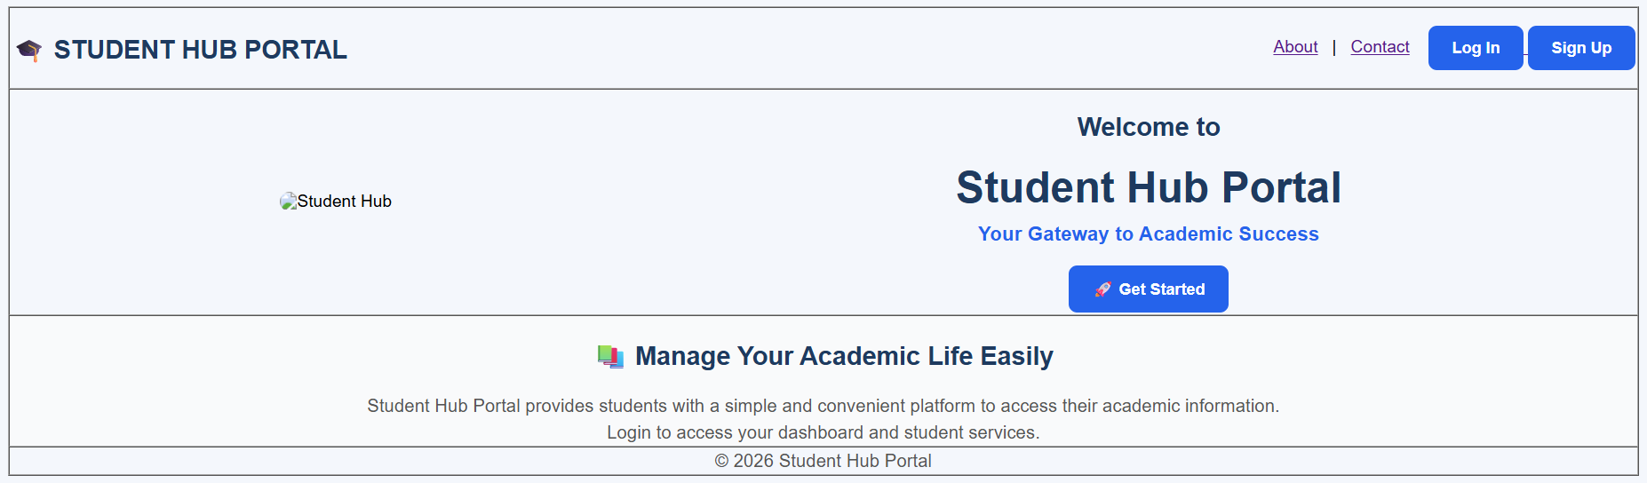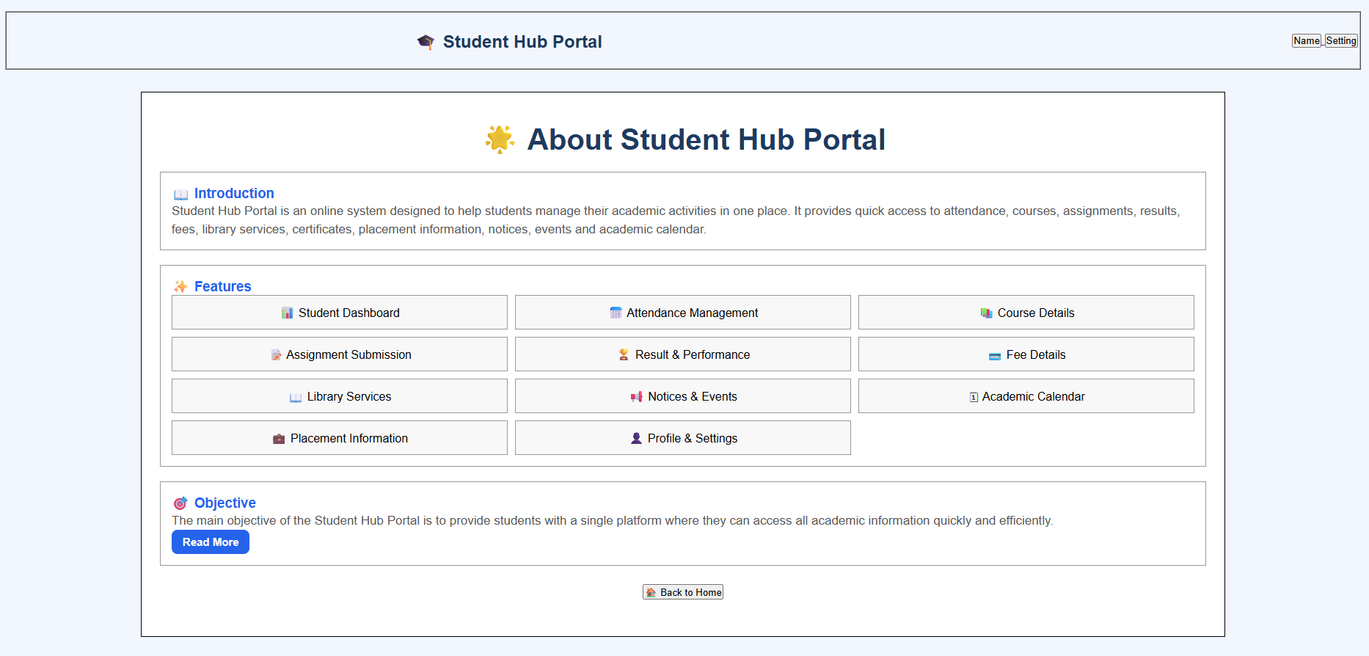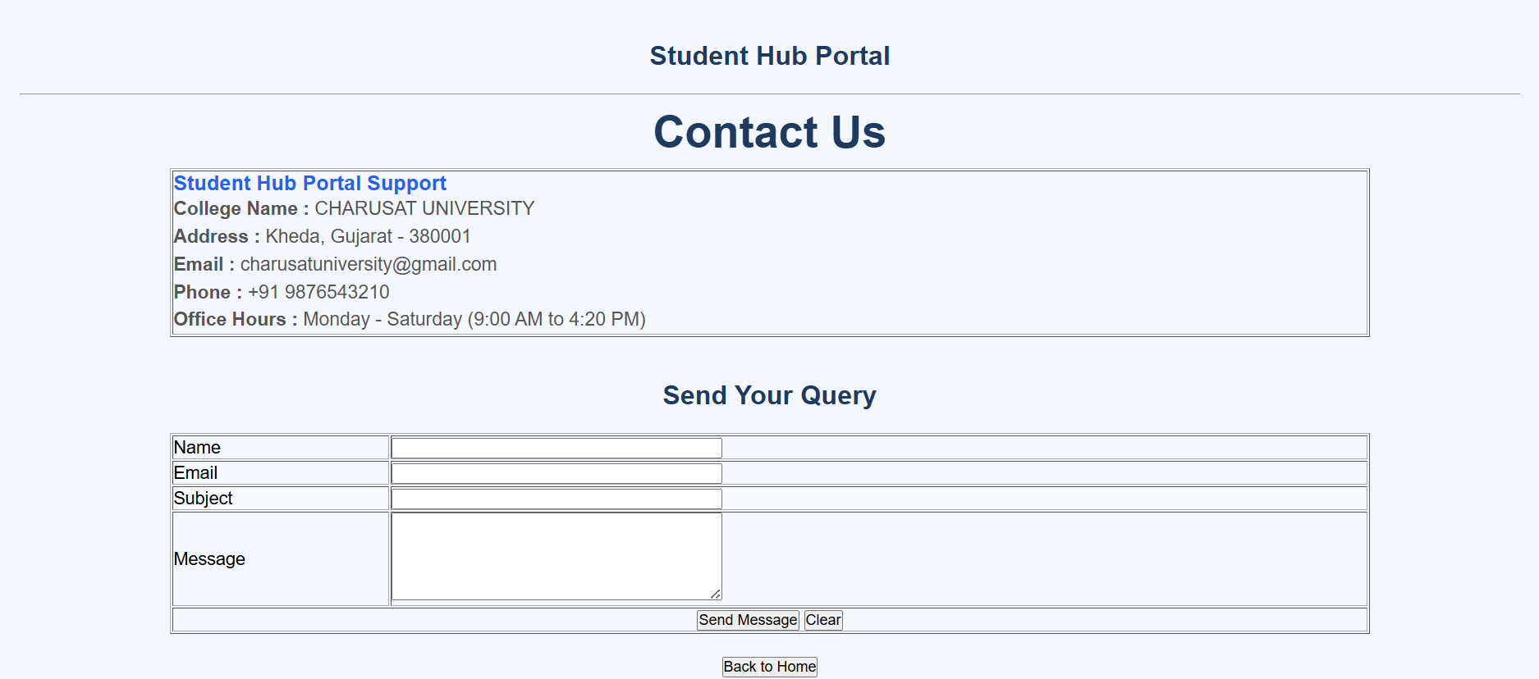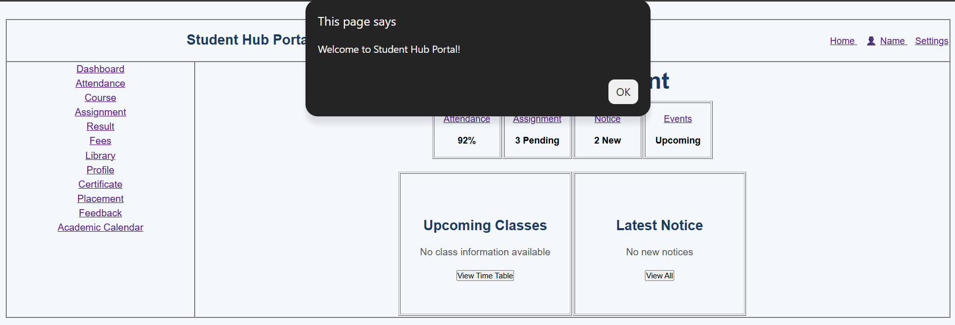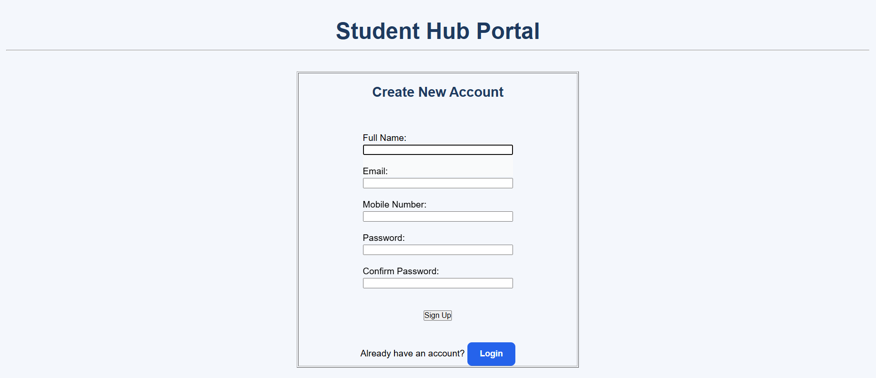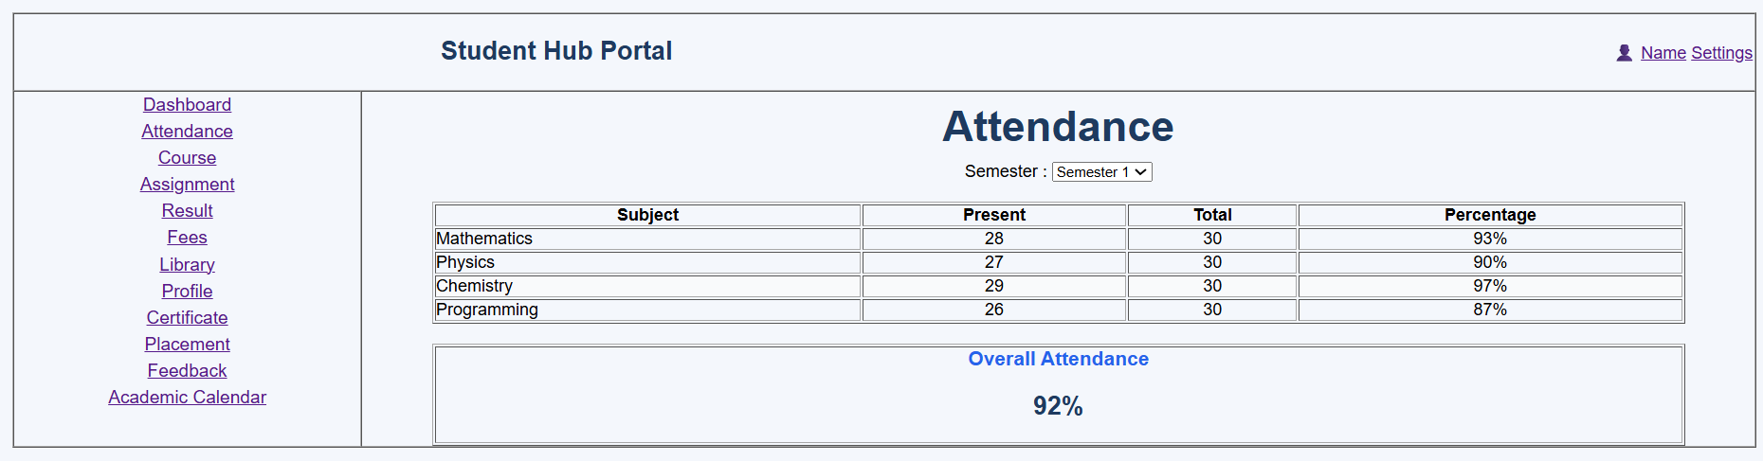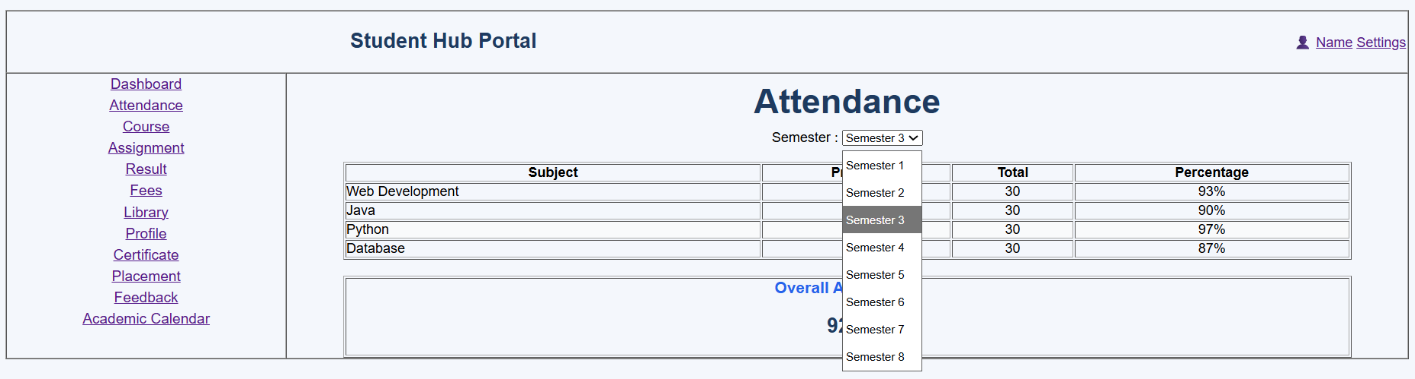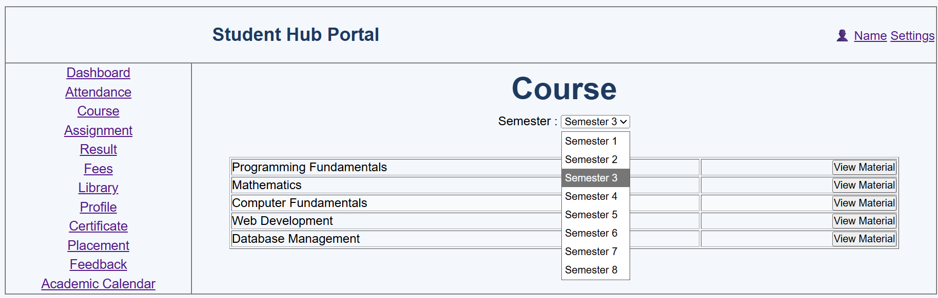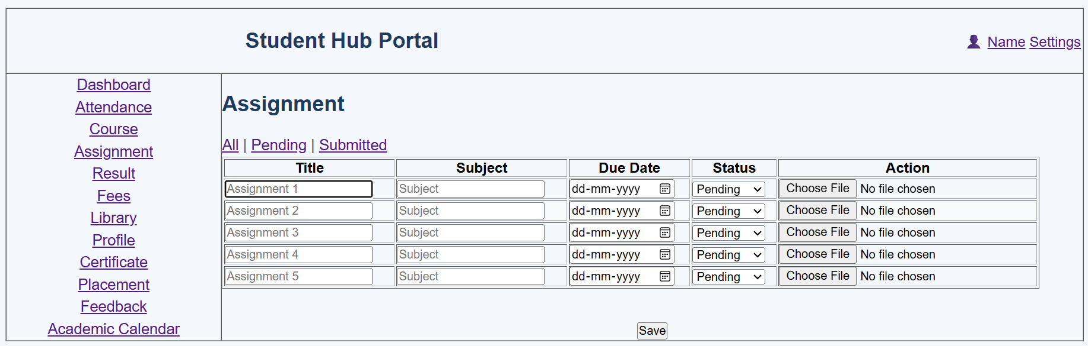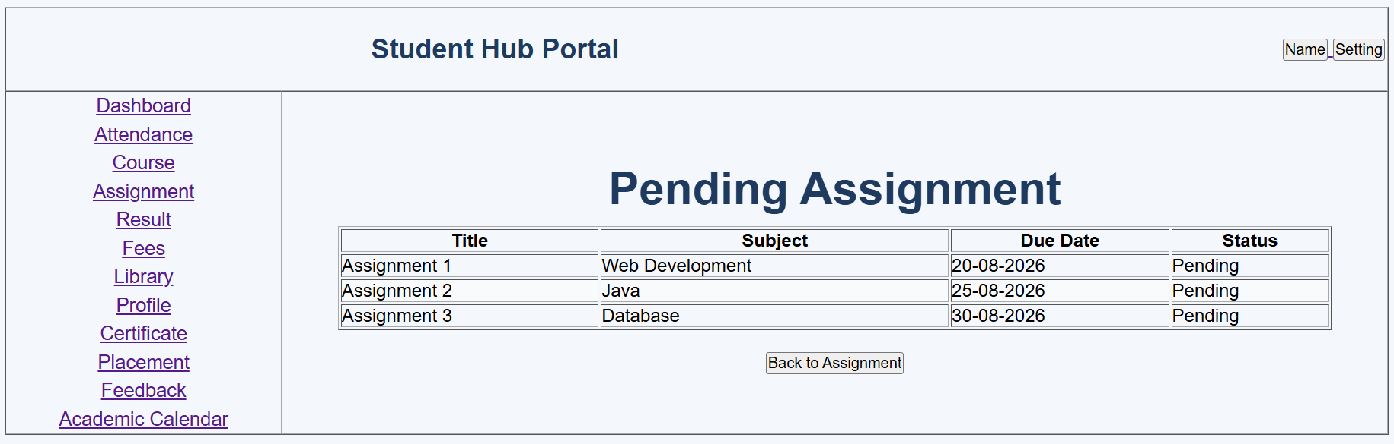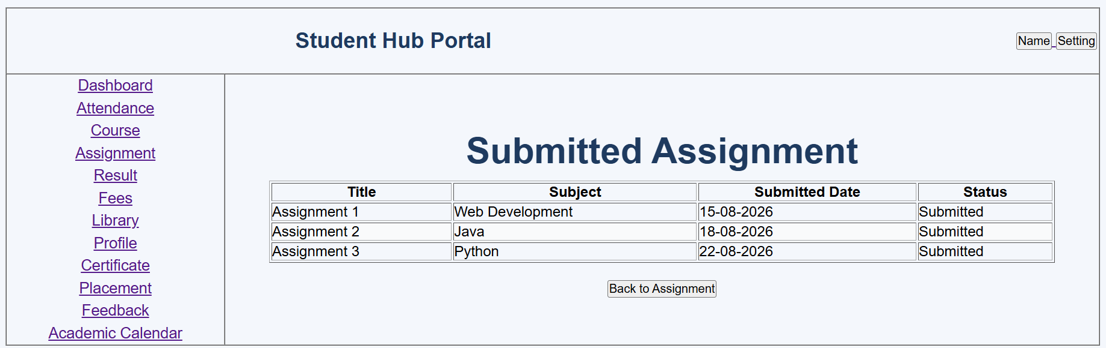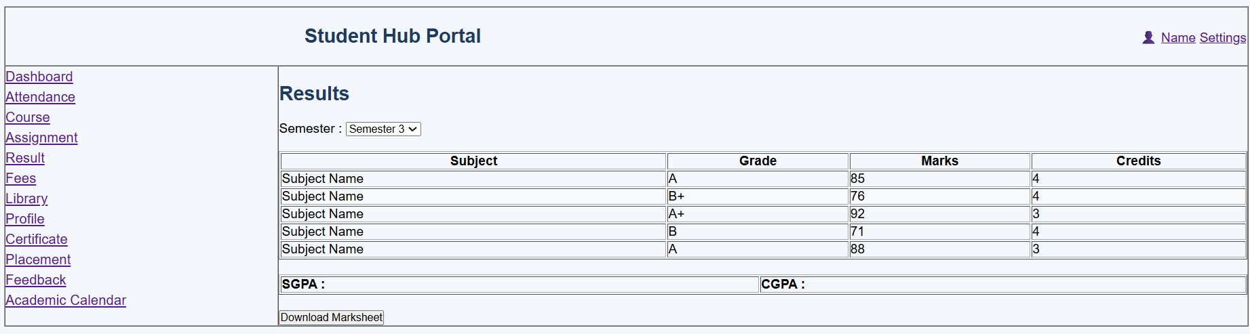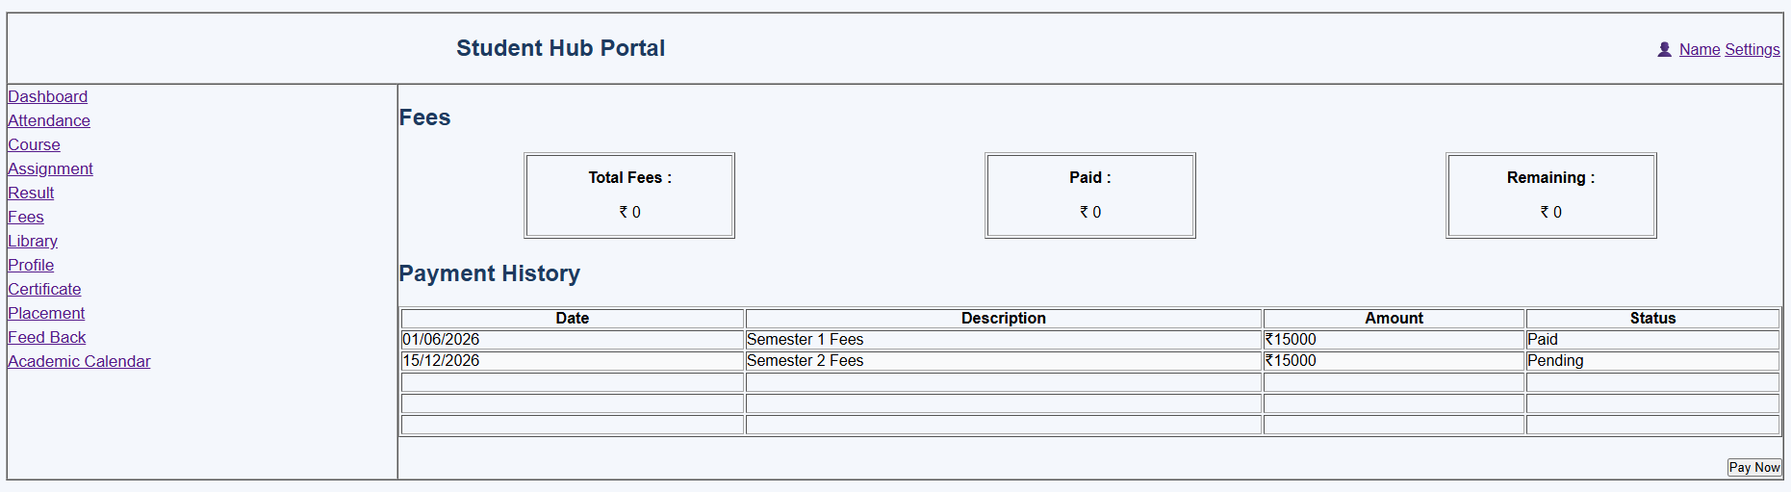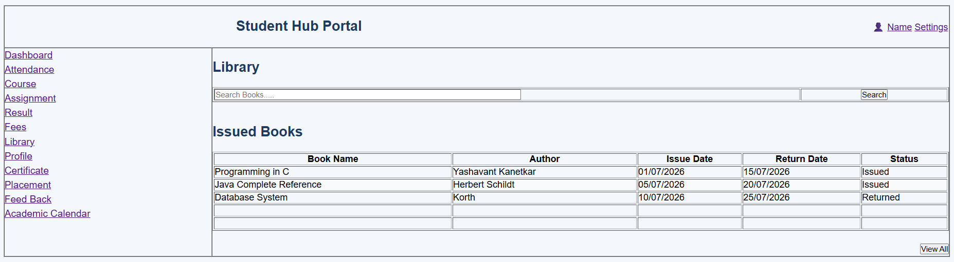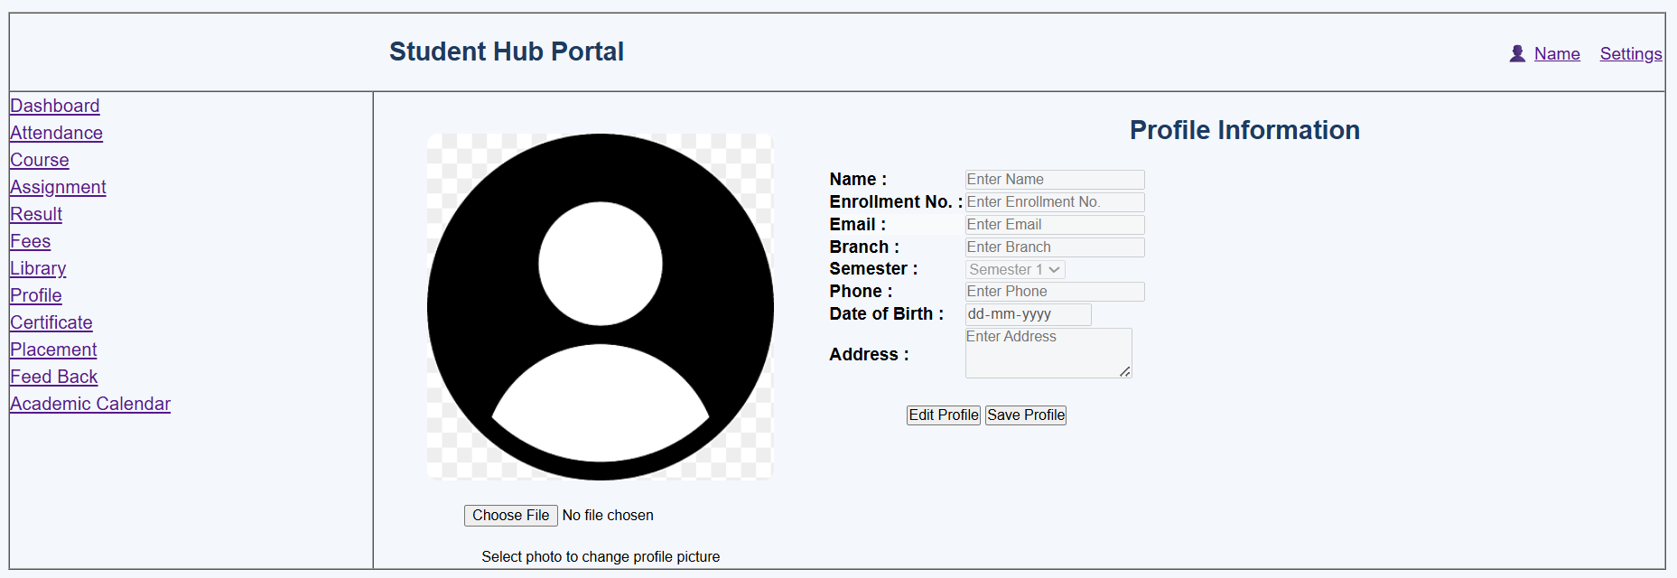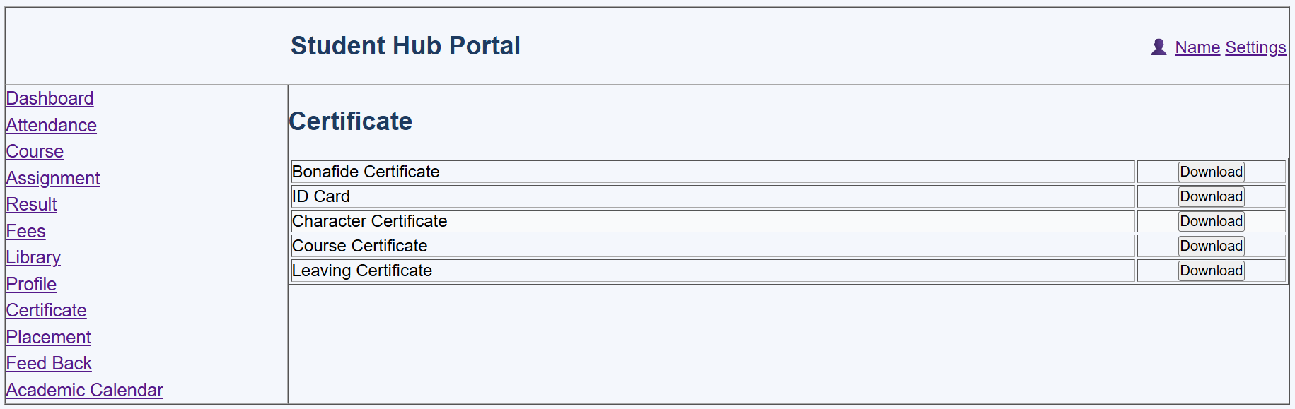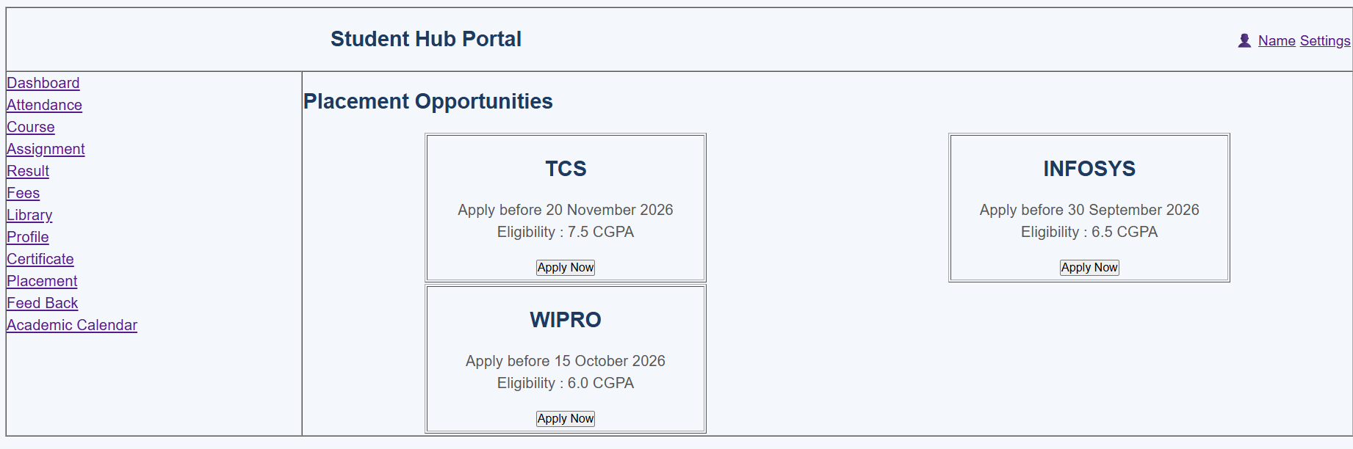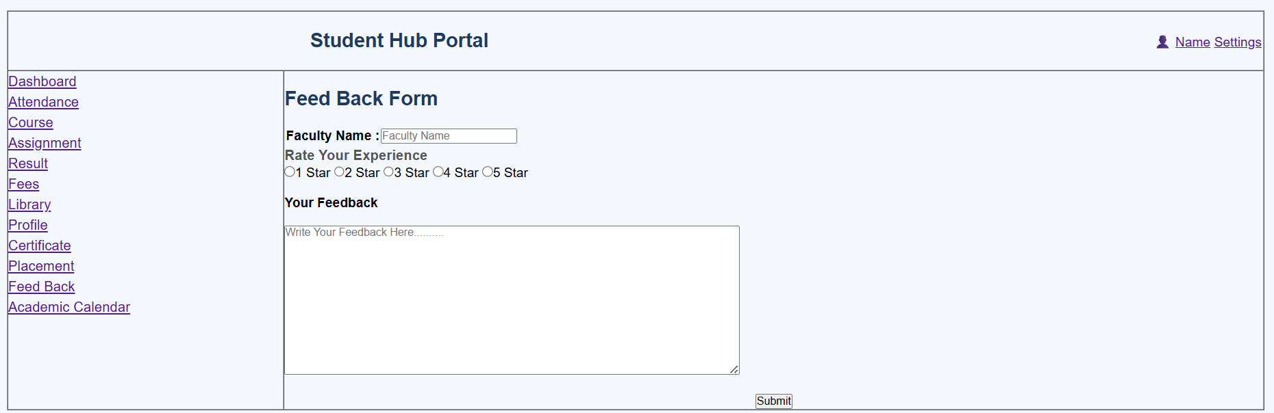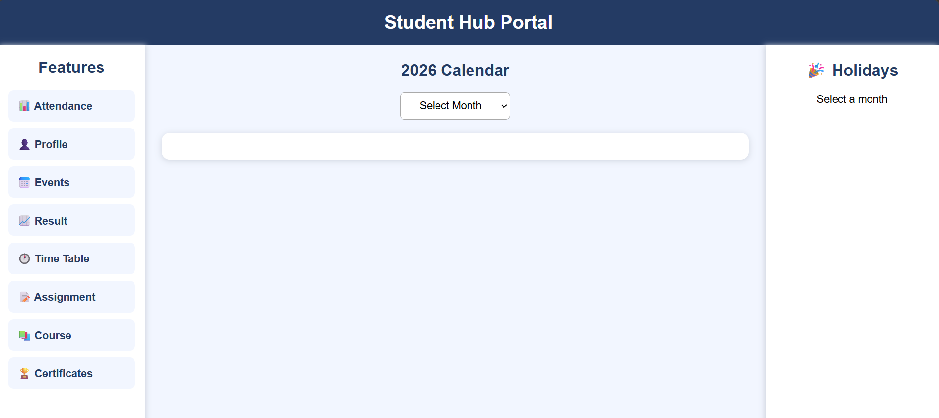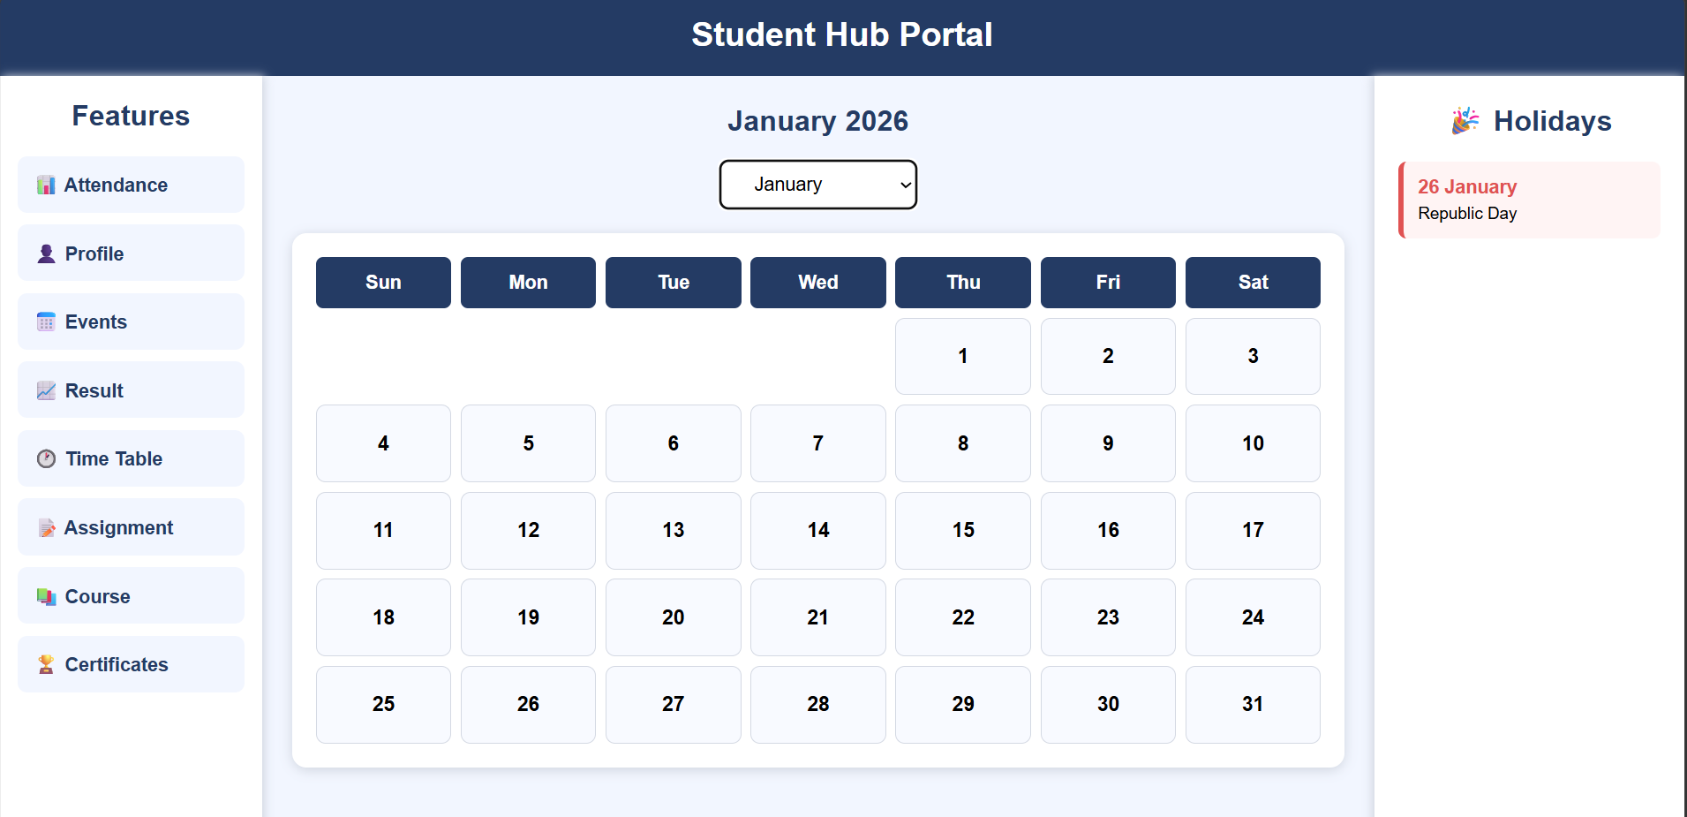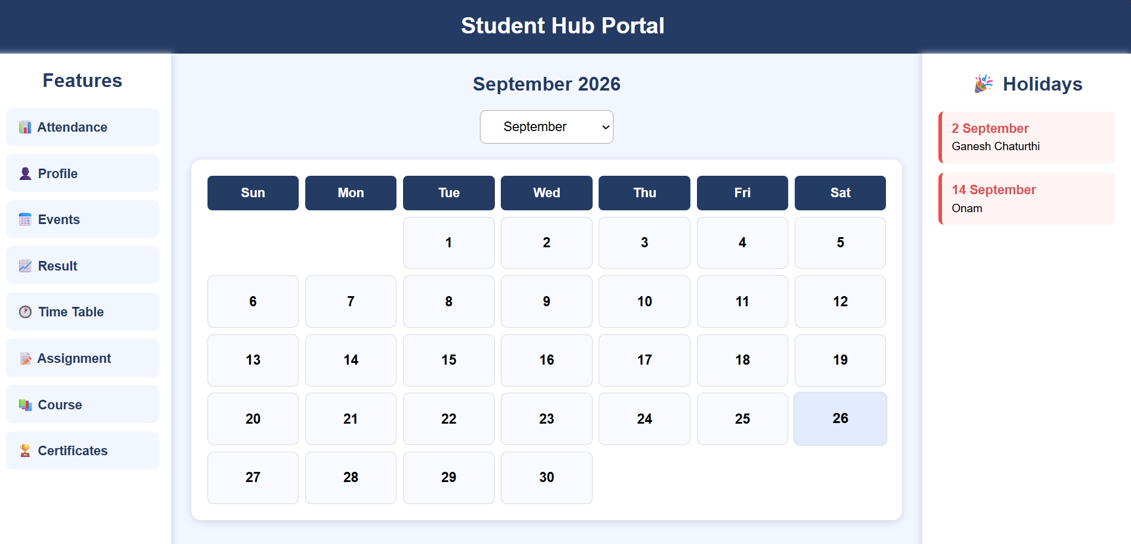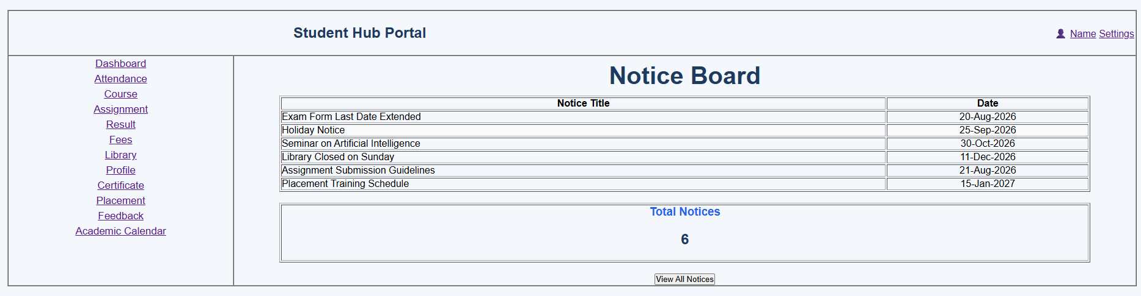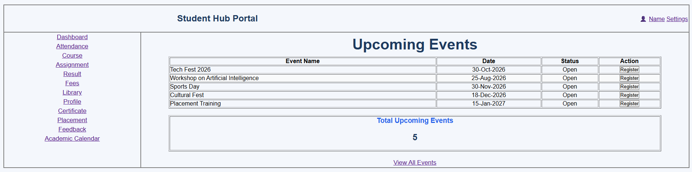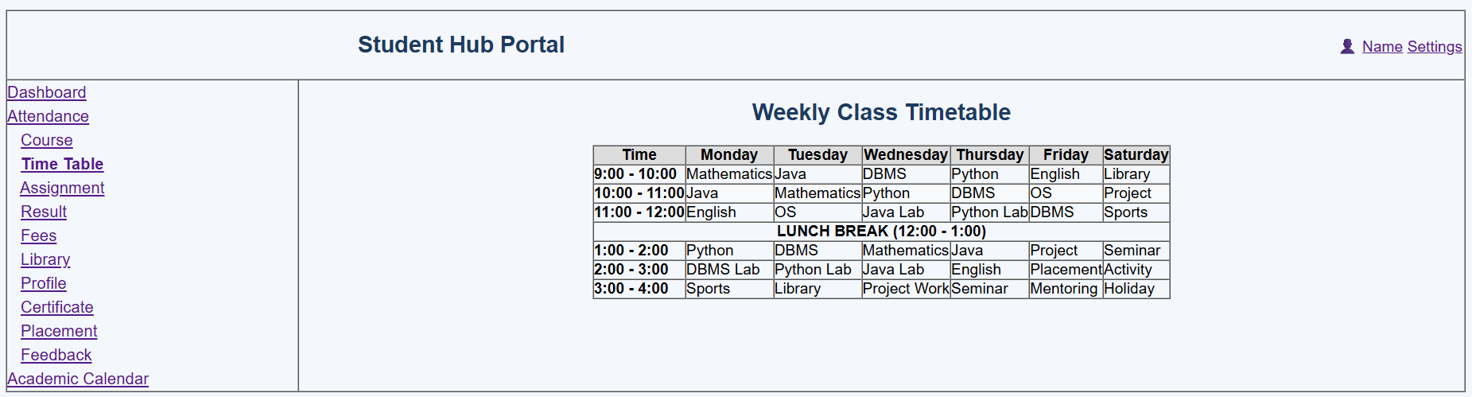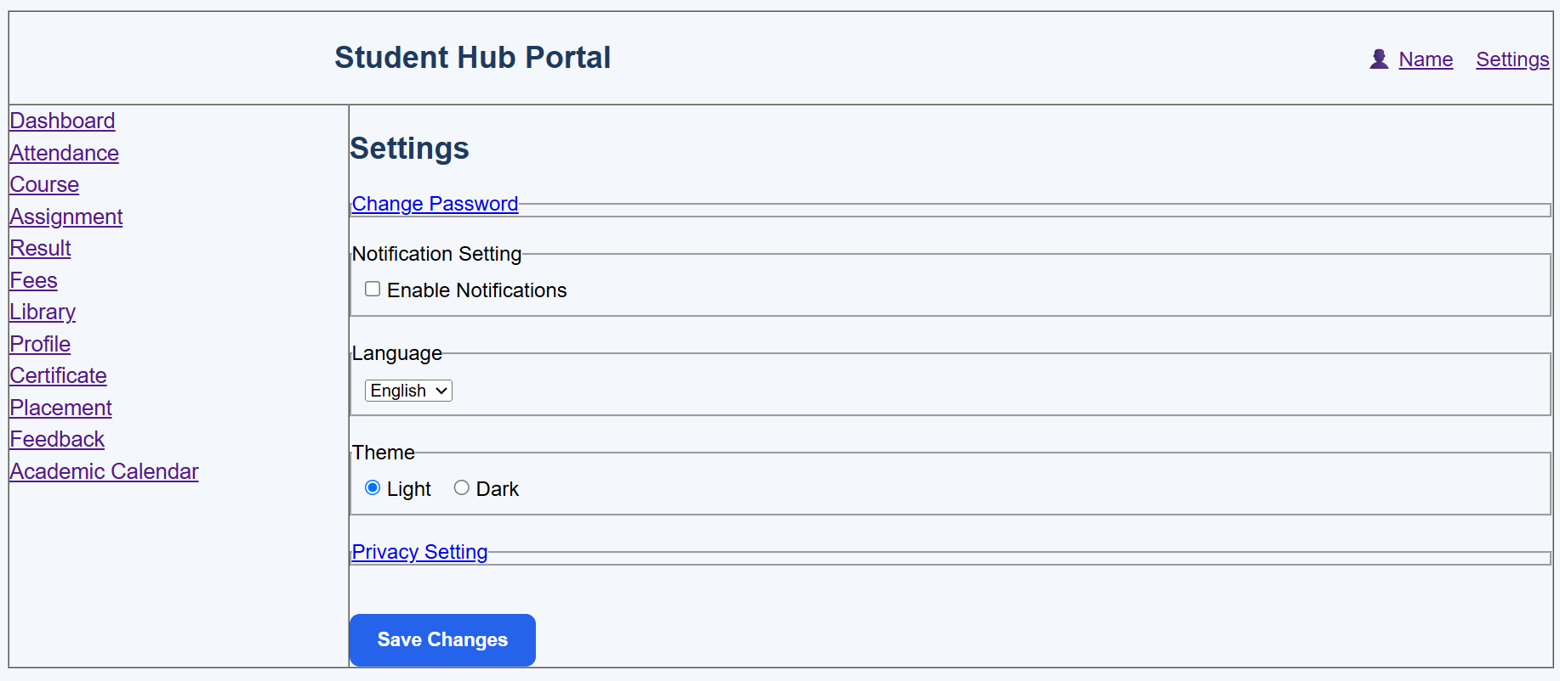

GitHub Repository Link:

https://github.com/Andarpadhruvi1125/Student-Hub-portal.git

C. Challenges Faced:
When I started working with JavaScript, I tried several times to display a pop-up message, but I faced different errors. Whenever I fixed one error, another error appeared. After repeated attempts and debugging, I was finally able to solve the issue. I then tried implementing other functions, where I faced some minor errors as well. I was able to solve some of them, while a few functions are still not working completely. This experience helped me improve my debugging skills and understand JavaScript functions better.
D. Learning Outcomes:

After completing this practical, students will be able to understand and apply JavaScript DOM manipulation and event handling to create dynamic and interactive web pages. They will learn to develop UI components such as collapsible FAQs, modal popups, sliders, notification banners, hamburger menus, and light/dark theme switchers. Students will also gain practical knowledge of class manipulation, basic animations, browser developer tools, and localStorage for saving and restoring user preferences, while improving the usability, responsiveness, and accessibility of web interfaces.

Faculty Remarks: (Keep this blank for faculty)

